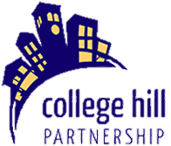
Agenda
The College Hill Partnership
Monday May 11th, 2020
at 7:00pm Via Zoom
College Hill Partnership Mission Statement
College Hill Partnership (CHP) is a non-profit organization that serves as the leader in revitalization and promotion of the College Hill area, an urban neighborhood community. The scope of its mission includes promoting healthy neighborhood businesses and housing enhancement; strengthening collaboration and pride; developing public/private partnerships; and serving as an advocate for addressing area concerns.

- Call to order

- Approval of 2019 Annual Meeting Minutes

- College Hill Farmers Market Report -- Jodie Huegerich

- Report From President -- Dave Deibler

- Report From Executive Director -- Kathryn Sogard
  - Election Rules

- Actionable Business/ Agenda Items
  - Board Election
    - Introduce Candidates/Opportunity for Candidates to Speak
    - Nominations from the Floor

- Other Business/Forum

- Adjourn

